实验-------GDI与Windows绘图

学生姓名：张哲超 专业班级：计算机192
课程名称：Windows程序设计 实验类型：综合

一 实验目的
熟悉Windows编程的基本结构和框架，实现一个基本的Windows窗口程序。在此基础上，练习GDI（图形设备接口）编程。重点掌握Windows操作系统中的GDI环境获取、句柄、画笔、画刷、RGB颜色、常用的绘图函数等编程技术和应用。

二 实验环境
PC机 + Windows 操作系统 + Visual C++

三 实验内容
实验题目1 按’R’键，整个窗体画红色；
按’G’键，整个窗体画绿色；
按’B’键，整个窗体画蓝色；
按 UP 键，在正中央显示“您按下了UP键”；
按 CTRL键，在正中央显示“您按下了CTRL键”；
按’Ctrl’+’R’键，整个窗体画橘红色；
按’Shift+’B’键，整个窗体画紫色。

实验过程1（思路（文字描述）、关键代码（WndProc 函数））
LRESULT CALLBACK WndProc(HWND hWnd,UINT message,WPARAM wParam,LPARAM lParam)
{
HDC hDC; //定义设备环境句柄.
HBRUSH hBr;
HPEN hPen;
PAINTSTRUCT ps; //定义包含绘图信息的结构体变量
char cUP[]="您按下了UP键";
char cCTRL[]="您按下了CTRL键";
static int i=0;
static int flag=0;
static bool nCtrlRKeyDown = FALSE;
static bool nCtrlKeyDown = FALSE;
static bool nShiftBKeyDown = FALSE;
static bool nShiftKeyDown = FALSE;
RECT rect;
GetClientRect(hWnd , &rect) ;

switch(message)
{
case WM_KEYUP:
InvalidateRect(hWnd,NULL,1); //刷新用户区。
break;

case WM_CHAR:
if(wParam=='r')
{
flag = 1;
}
else if(wParam=='g') //当按下b键时
{
flag = 2;
}
else if(wParam=='b') //当按下c键时
{
flag = 3;
}
else if((GetAsyncKeyState(VK_CONTROL&0x8000)) && (GetAsyncKeyState('R'))){
if(nCtrlKeyDown == TRUE){
nCtrlRKeyDown = TRUE;
nCtrlKeyDown = FALSE;
}
}
else if((GetAsyncKeyState(VK_SHIFT&0x8000)) && (GetAsyncKeyState('B'))){
if(nShiftKeyDown == TRUE){
nShiftBKeyDown = TRUE;
nShiftKeyDown = FALSE;
}
}
break;

case WM_KEYDOWN:
if(wParam == VK_UP){
flag = 4;
}else if(wParam == VK_CONTROL){
nCtrlKeyDown = TRUE;
flag = 5;
}else if(wParam == VK_SHIFT){
nShiftKeyDown = TRUE;
flag = 6;
}
break;

case WM_PAINT: //处理绘图消息.
hDC=BeginPaint(hWnd,&ps);
SetTextColor(hDC,RGB(255,0,0)); //设置字体颜色为红色。

//输出信息。
if(flag == 1)
{
hPen = CreatePen(PS_SOLID, 1, RGB(0,0,0));
SelectObject(hDC, hPen);
hBr = CreateSolidBrush(RGB(255,0,0));
SelectObject(hDC, hBr);
Rectangle(hDC, rect.left, rect.top, rect.right, rect.bottom);
DeleteObject(hPen);
DeleteObject(hBr);
}
else if(flag == 2)
{
hPen = CreatePen(PS_SOLID, 1, RGB(0,0,0));
SelectObject(hDC, hPen);
hBr = CreateSolidBrush(RGB(0,255,0));
SelectObject(hDC, hBr);
Rectangle(hDC, rect.left, rect.top, rect.right, rect.bottom);
DeleteObject(hPen);
DeleteObject(hBr);
}
else if(flag == 3)
{
hPen = CreatePen(PS_SOLID, 1, RGB(0,0,0));
SelectObject(hDC, hPen);
hBr = CreateSolidBrush(RGB(0,0,255));
SelectObject(hDC, hBr);
Rectangle(hDC, rect.left, rect.top, rect.right, rect.bottom);
DeleteObject(hPen);
DeleteObject(hBr);
}
else if(flag == 4){
TextOut(hDC, (rect.left+rect.right)/2, (rect.top+rect.bottom)/2, cUP, strlen(cUP));
}
else if(flag == 5){
if(!nCtrlRKeyDown)
TextOut(hDC, (rect.left+rect.right)/2, (rect.top+rect.bottom)/2, cCTRL, strlen(cCTRL));
else{
hPen = CreatePen(PS_SOLID, 1, RGB(0,0,0));
SelectObject(hDC, hPen);
hBr = CreateSolidBrush(RGB(255,104,24));
SelectObject(hDC, hBr);
Rectangle(hDC, rect.left, rect.top, rect.right, rect.bottom);
DeleteObject(hPen);
DeleteObject(hBr);
}
}
else if(flag == 6){
if(nShiftBKeyDown)
hPen = CreatePen(PS_SOLID, 1, RGB(0,0,0));
SelectObject(hDC, hPen);
hBr = CreateSolidBrush(RGB(236,24,255));
SelectObject(hDC, hBr);
Rectangle(hDC, rect.left, rect.top, rect.right, rect.bottom);
DeleteObject(hPen);
DeleteObject(hBr);
}
EndPaint(hWnd,&ps);
break;

case WM_DESTROY:
PostQuitMessage(0);
return 0;
default:
return DefWindowProc(hWnd,message,wParam,lParam);
}
return 0;
}
实验结果1
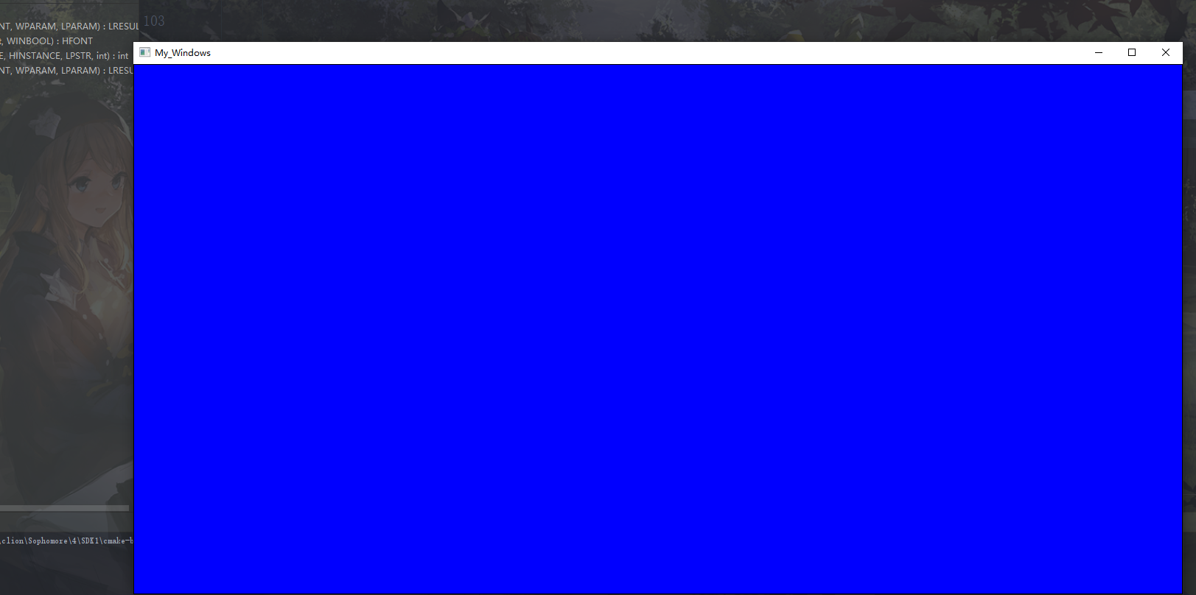

实验题目2 窗体正中央每隔2秒随意显示一个黑色数字（0-9），用户按相应的数字键，如果按键正确，则数字颜色变为蓝色；如果按键错误，则数字颜色变为红色。

实验过程2（思路（文字描述）、关键代码（WndProc 函数））
LRESULT CALLBACK WndProc(HWND hWnd,UINT message,WPARAM wParam,LPARAM lParam)
{
HDC hDC; //定义设备环境句柄.
HBRUSH hBr;
HPEN hPen;
PAINTSTRUCT ps; //定义包含绘图信息的结构体变量
char cUP[]="您按下了UP键";
char cCTRL[]="您按下了CTRL键";
char cNum[] = "0123456789";
static int i=0;
static int flag=-1;
static bool nCtrlRKeyDown = FALSE;
static bool nCtrlKeyDown = FALSE;
static bool nShiftBKeyDown = FALSE;
static bool nShiftKeyDown = FALSE;
RECT rect;
static int out = 1;
GetClientRect(hWnd , &rect) ;

switch(message)
{
case WM_CREATE:
srand(time(NULL));
SetTimer(hWnd,1,2000,NULL); //建立计时器,每2秒发出WM_TIMER消息.

case WM_KEYUP:
InvalidateRect(hWnd,NULL,1); //刷新用户区。
break;

case WM_TIMER: //处理由计时器发出的消息.
i = rand()%10;
InvalidateRect(hWnd,NULL,1); //刷新用户区.
break;

case WM_CHAR:
if(wParam=='1')
{
flag = 1;
}
else if(wParam=='2') //当按下b键时
{
flag = 2;
}
else if(wParam=='3') //当按下c键时
{
flag = 3;
}
if(wParam=='4')
{
flag = 4;
}
else if(wParam=='5') //当按下b键时
{
flag = 5;
}
else if(wParam=='6') //当按下c键时
{
flag = 6;
}
if(wParam=='7')
{
flag = 7;
}
else if(wParam=='8') //当按下b键时
{
flag = 8;
}
else if(wParam=='9') //当按下c键时
{
flag = 9;
}
else if(wParam=='0') //当按下c键时
{
flag = 0;
}
break;

case WM_KEYDOWN:
break;

case WM_PAINT: //处理绘图消息.
hDC=BeginPaint(hWnd,&ps);
SetTextColor(hDC,RGB(0,255,0));
TextOut(hDC, (rect.left+rect.right)/2, (rect.top+rect.bottom)/2, &cNum[i], 1);
out = 1;
//输出信息。
if(flag == 1 && out == 1){
if(flag == i)
SetTextColor(hDC,RGB(0,0,255));
else
SetTextColor(hDC,RGB(255,0,0));

TextOut(hDC, (rect.left+rect.right)/2, (rect.top+rect.bottom)/2, &cNum[i], 1);
flag = -1;
out = 0;
}
else if(flag == 2 && out == 1){
if(flag == i)
SetTextColor(hDC,RGB(0,0,255));
else
SetTextColor(hDC,RGB(255,0,0));

TextOut(hDC, (rect.left+rect.right)/2, (rect.top+rect.bottom)/2, &cNum[i], 1);
flag = -1;
out = 0;

}

else if(flag == 3 && out == 1){
if(flag == i)
SetTextColor(hDC,RGB(0,0,255));
else
SetTextColor(hDC,RGB(255,0,0));

TextOut(hDC, (rect.left+rect.right)/2, (rect.top+rect.bottom)/2, &cNum[i], 1);
flag = -1;
out = 0;

}
else if(flag == 4 && out == 1){
if(flag == i)
SetTextColor(hDC,RGB(0,0,255));
else
SetTextColor(hDC,RGB(255,0,0));

TextOut(hDC, (rect.left+rect.right)/2, (rect.top+rect.bottom)/2, &cNum[i], 1);
flag = -1;
out = 0;

}
else if(flag == 5 && out == 1){
if(flag == i)
SetTextColor(hDC,RGB(0,0,255));
else
SetTextColor(hDC,RGB(255,0,0));

TextOut(hDC, (rect.left+rect.right)/2, (rect.top+rect.bottom)/2, &cNum[i], 1);
flag = -1;
out = 0;

}
else if(flag == 6 && out == 1){
if(flag == i)
SetTextColor(hDC,RGB(0,0,255));
else
SetTextColor(hDC,RGB(255,0,0));

TextOut(hDC, (rect.left+rect.right)/2, (rect.top+rect.bottom)/2, &cNum[i], 1);
flag = -1;
out = 0;

}
else if(flag == 7 && out == 1){
if(flag == i)
SetTextColor(hDC,RGB(0,0,255));
else
SetTextColor(hDC,RGB(255,0,0));

TextOut(hDC, (rect.left+rect.right)/2, (rect.top+rect.bottom)/2, &cNum[i], 1);
flag = -1;
out = 0;

}
else if(flag == 8 && out == 1){
if(flag == i)
SetTextColor(hDC,RGB(0,0,255));
else
SetTextColor(hDC,RGB(255,0,0));

TextOut(hDC, (rect.left+rect.right)/2, (rect.top+rect.bottom)/2, &cNum[i], 1);
flag = -1;
out = 0;

}
else if(flag == 9 && out == 1){
if(flag == i)
SetTextColor(hDC,RGB(0,0,255));
else
SetTextColor(hDC,RGB(255,0,0));

TextOut(hDC, (rect.left+rect.right)/2, (rect.top+rect.bottom)/2, &cNum[i], 1);
flag = -1;
out = 0;

}
else if(flag == 0 && out == 1){
if(flag == i)
SetTextColor(hDC,RGB(0,0,255));
else
SetTextColor(hDC,RGB(255,0,0));

TextOut(hDC, (rect.left+rect.right)/2, (rect.top+rect.bottom)/2, &cNum[i], 1);
flag = -1;
out = 0;

}

EndPaint(hWnd,&ps);
break;

case WM_DESTROY:
PostQuitMessage(0);
return 0;
default:
return DefWindowProc(hWnd,message,wParam,lParam);
}
return 0;
}
实验结果2:
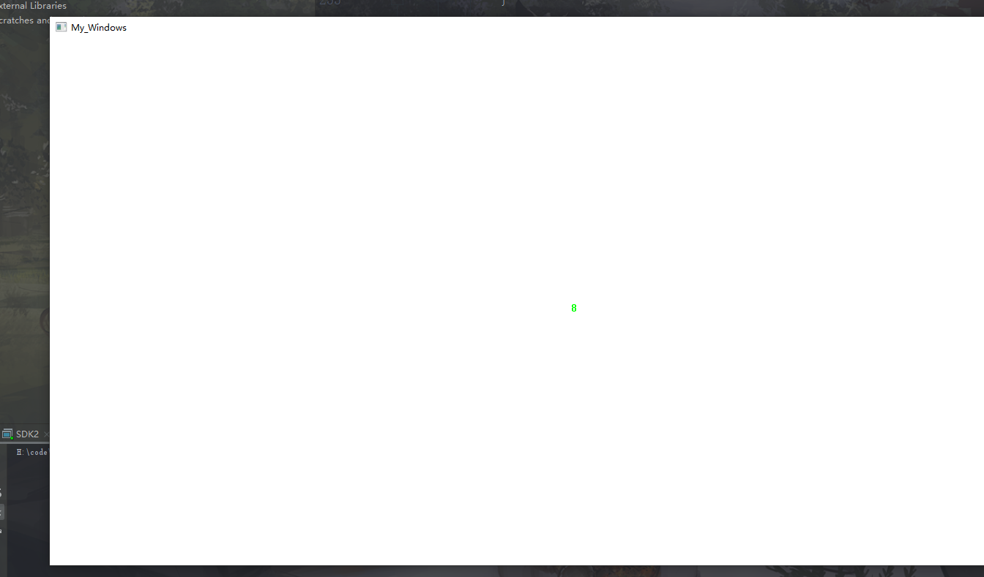

实验题目3 窗体正中央放置一个红色小球，用户可通过w,a,s,d键或上下左右键，使小球按相应方向进行移动，可以四方向，也可以八方向。碰到边界能合理变向。

实验过程3（思路（文字描述）、关键代码（WndProc 函数））
LRESULT CALLBACK WndProc(HWND hWnd,UINT message,WPARAM wParam,LPARAM lParam)
{
HDC hDC; //定义设备环境句柄.
HBRUSH hBr;
HPEN hPen;
PAINTSTRUCT ps; //定义包含绘图信息的结构体变量
static int i=0;
static int flag=0;
// static bool nCtrlRKeyDown = FALSE;
// static bool nCtrlKeyDown = FALSE;
// static bool nShiftBKeyDown = FALSE;
// static bool nShiftKeyDown = FALSE;
static double x1, x2, y1, y2;
RECT rect;
GetClientRect(hWnd , &rect) ;

switch(message)
{
case WM_CREATE:
x1 = (rect.left+rect.right)/2.4;
x2 = (rect.left+rect.right)/1.9;
y1 = (rect.top+rect.bottom)/3;
y2 = (rect.top+rect.bottom)/1.8;
break;
case WM_KEYUP:
InvalidateRect(hWnd,NULL,1); //刷新用户区。
break;

case WM_CHAR:
if(wParam == 'w'){
flag = 1;
}else if(wParam == 's'){
flag = 2;
}else if(wParam == 'a'){
flag = 3;
}else if(wParam == 'd'){
flag = 4;
}
break;

case WM_KEYDOWN:
if(wParam == VK_UP){
flag = 1;
}else if(wParam == VK_DOWN){
flag = 2;
}else if(wParam == VK_LEFT){
flag = 3;
}else if(wParam == VK_RIGHT){
flag = 4;
}
break;

case WM_PAINT: //处理绘图消息.

if(flag == 1)//向上
{
y1 -= 50;
y2 -= 50;
if(rect.top >= y1){
y1 += 100;
y2 += 100;
}
// flag = 0;
}
else if(flag == 2)//向下
{
y1 += 50;
y2 += 50;
if(rect.bottom <= y2){
y1 -= 100;
y2 -= 100;
}

// flag = 0;
}
else if(flag == 3)//向左
{
x1 -= 50;
x2 -= 50;
if(rect.left >= x1){
x1 += 100;
x2 += 100;
}
// flag = 0;
}
else if(flag == 4)//向右
{
x1 += 50;
x2 += 50;
if(rect.right <= x2){
x1 -= 100;
x2 -= 100;
}
// flag = 0;
}
hDC=BeginPaint(hWnd,&ps);
hPen = CreatePen(PS_SOLID, 1, RGB(255,0,0));
SelectObject(hDC, hPen);
hBr = CreateSolidBrush(RGB(255,0,0));
SelectObject(hDC, hBr);
Ellipse(hDC, x1, y1, x2, y2);
DeleteObject(hPen);
DeleteObject(hBr);
// flag = 0;
EndPaint(hWnd,&ps);
break;

case WM_DESTROY:
PostQuitMessage(0);
return 0;
default:
return DefWindowProc(hWnd,message,wParam,lParam);
}
return 0;
}
实验结果3
